Uniform Chart of Accounts Grant Programs 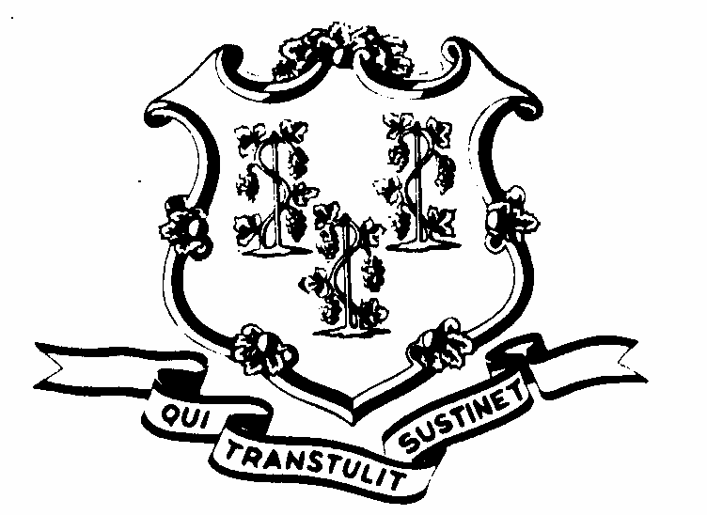
Application for State Award
SLFAC Grant Program

Office of Policy and Management Rev.09/2014
Pursuant to Sec. 328 (b) of P.A. 13-247 Form SLFASC-1

This application is to be used by entities that have formed a collaboration to apply for a state award for implementing the State developed uniform chart of accounts (UCOA) under the Small Localities Financial Accounting System Collaboration (SLFASC) Grant Program whereby two or more municipalities with populations generally of 15,000 or under, or two or more regional school districts (including charter schools and regional education service centers) apply for grant funding for entering into a collaboration to share a common financial accounting system that incorporates the State developed UCOA. A separate application is available for individual entities wishing to apply for the UCOA Conversion Grant Program. Both a completed hardcopy and electronic version of this application are required to be submitted as indicated below.

Submit application (hardcopy) to: Office of Policy and Management,
450 Capitol Ave. MS #54 ORG
Hartford, CT 06106-1379
Att: UCOA Grant Program

Submit electronic version of application to: eric.k.lindquist@ct.gov

Type of Entities Participating in the | Municipality
Collaboration: (check all that apply) | Regional School District
 | Regional Education Service Center
 | Charter School
 | Other (describe below)
Name of Fiduciary or Lead Entity:
Name of collaborating entities other than municipalities:

For each participating municipality
In the collaboration, provide the following information:

Name of Municipality:
Does the municipality have a board of education?  (If yes, answer the question below) | Yes No
This application is on behalf of:  (check either box A or B) | - Both the municipality & its board of  education  - The Municipal Government Only
Name of Municipality:
Does the municipality have a board of education?  (If yes, answer the question below) | Yes No
This application is on behalf of:  (check either box A or B) | - Both the municipality & its board of  education  - The Municipal Government Only
Name of Municipality:
Does the municipality have a board of education?  (If yes, answer the question below) | Yes No
This application is on behalf of:  (check either box A or B) | - Both the municipality & its board of  education  - The Municipal Government Only
Name of Municipality:
Does the municipality have a board of education?  (If yes, answer the question below) | Yes No
This application is on behalf of:  (check either box A or B) | - Both the municipality & its board of  education  - The Municipal Government Only
(Please attach additional sheets if necessary for additional municipalities)

Contact Person for the Application:
Name
Title
Address
City/State/Zip
Telephone
Fax
E-mail

Provide a description or objective of the collaboration. Please include an estimated timeline to develop and share a common accounting system that incorporates the State developed UCOA. Describe how the collaboration is anticipated to achieve savings for participants in the collaboration and/or how the collaboration is anticipated to improve the accounting systems of the participants in the collaboration.

Certification by the CEO of the Applicant Entity (i.e. fiduciary/lead entity):
I do hereby certify that the information contained herein is true and accurate to the best of my knowledge and understand that proofs of endorsement from the legislative bodies of all participating entities in this collaboration must be submitted within 90 days of preliminary grant approval.
Signature:
Name:
Title:
Date:

Please contact Eric Lindquist at 860-418-6395 or at eric.k.lindquist@ct.gov should you have any questions.

