Uniform Chart of Accounts Grant Programs 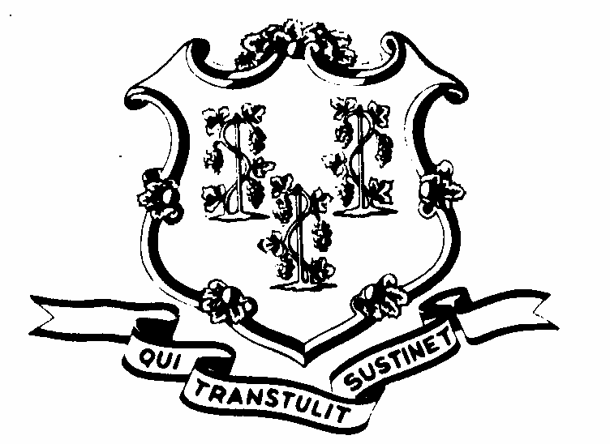
Application for State Award
UCOA Conversion Grant

Office of Policy and Management Rev.09/2014
Pursuant to Sec. 328 (b) of P.A. 13-247 Form UCOA Conversion-1

This application is to be used by an entity in applying for a state award for implementing the State developed uniform chart of accounts (UCOA) under the UCOA Conversion Grant Program whereby an entity applies for grant funding for upgrading its current financial accounting system or changing its current financial accounting system including conversion from its current local chart of accounts to the State developed UCOA as part of the upgrade or change in financial accounting system; A separate application is available for a collaboration of entities to apply for the Small Localities Financial Accounting System Collaboration (SLFASC) Grant Program. Both a completed hardcopy and electronic version of this application are required to be submitted as indicated below.

Submit application (hardcopy) to: Office of Policy and Management,
450 Capitol Ave. MS #54 ORG
Hartford, CT 06106-1379
Att: UCOA Grant Program

Submit electronic version of application to: eric.k.lindquist@ct.gov

Name of Applying Entity
Type of Entity (check applicable box) | Municipality
 | Regional School District
 | Regional Education Service Center
 | Charter School
 | Other (describe below)
If the applicant is a municipality, does  the municipality have a board of education?  (If yes, answer the question below) | Yes No
This application is on behalf of:  (check either box A or B) | - Both the municipality & its board of  education  - The Municipal Government Only
Contact Person for the Application:
Name
Title
Address
City/State/Zip
Telephone
Fax
E-mail
Number of years current financial system has been in use:
Provide a brief description of current financial accounting system in use
Describe the upgrade or change in financial accounting system anticipated. Please include an estimated timeline to implement the upgrade or change in accounting system, including conversion and implementation of the State developed UCOA.

Certification by the Chief Executive Officer of the Applicant Entity:
I do hereby certify that the information contained herein is true and accurate to the best of my knowledge, and understand that proof of endorsement from the legislative body of the applicant organization must be submitted within 90 days of preliminary grant approval.
Signature:
Name:
Title:
Date:

Please contact Eric Lindquist at 860-418-6395 or at eric.k.lindquist@ct.gov should you have any questions.

